Tesla Girl X Profile and Posts
English account copy and eight posts with matched red and white character artwork.

Profile bio
Tesla Girl | Red & white anime energy meets AI agent culture. Exploring on-chain ideas, market signals and a community with a spark.

Project introduction
Tesla Girl is an anime-inspired crypto community built around a red-and-white AI trading character. She brings a curious, observant personality to conversations about on-chain markets and the future of AI agents. Our direction is to make market exploration more expressive, approachable and community driven through character, shared ideas and clear visual storytelling. Stay curious. Read the signals. Find your spark.

Account artwork
Display name: Tesla Girl
Avatar: images/avatar-512.jpg
Header: images/header-750x250.jpg
Community: https://x.com/BILUAIAGENT
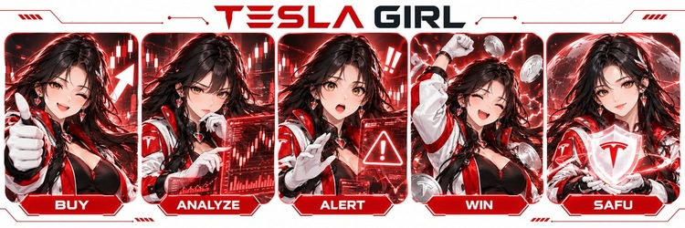

Introduction and discovery
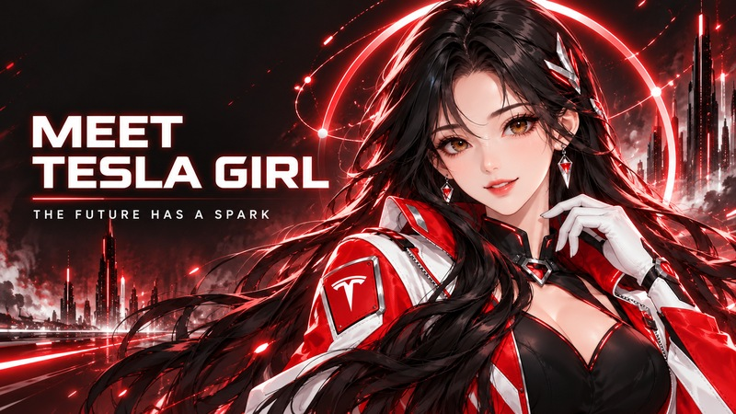

Post 01 Meet Tesla Girl
Meet Tesla Girl.
Red & white. Electric curiosity. An anime-inspired community exploring on-chain ideas and the future of AI agents.
Stay curious. Read the signals. Find your spark.
#TeslaGirl #AIAgents
Image: 01-meet-tesla-girl.jpg

Post 02 Read the signals
A chart can catch your eye. A better question can change your perspective.
Tesla Girl brings curiosity to market culture: observe, question, then form your own view.
What is the first signal you look for?
#TeslaGirl #Crypto
Image: 02-read-the-signals.jpg

Post 03 Find your spark
Every community starts with a spark.
A shared idea. A favorite character. A question worth exploring together.
Welcome to Tesla Girl. What brought you here: anime, crypto or AI agents?
#TeslaGirl #Community
Image: 03-find-your-spark.jpg

Character and market culture
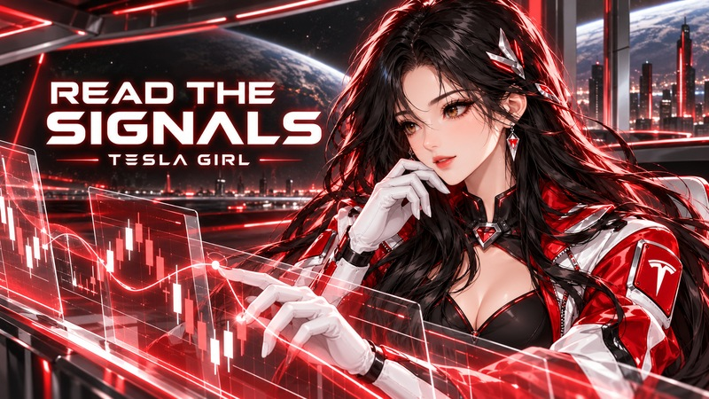

Post 04 Red and white identity
Red jacket. White gloves. Electric attitude.
Tesla Girl brings a bold anime identity to crypto culture.
Which detail is your favorite: the outfit, the electric halo or the holographic charts?
#TeslaGirl #AnimeArt
Image: tesla-girl-hero.jpg

Post 05 Agent culture
One character. Five moods.
BUY. ANALYZE. ALERT. WIN. SAFU.
Tesla Girl explores the personalities behind market decisions and the possibilities of AI agent culture.
Which mood are you today?
#TeslaGirl #AIAgents
Image: tesla-girl-abilities.jpg

Post 06 Questions before conviction
Before the next hot take, ask one more question.
What changed? What is missing? What would change your mind?
That is the energy Tesla Girl brings to the conversation.
#TeslaGirl #MarketCulture
Image: 02-read-the-signals.jpg

Community and conversation
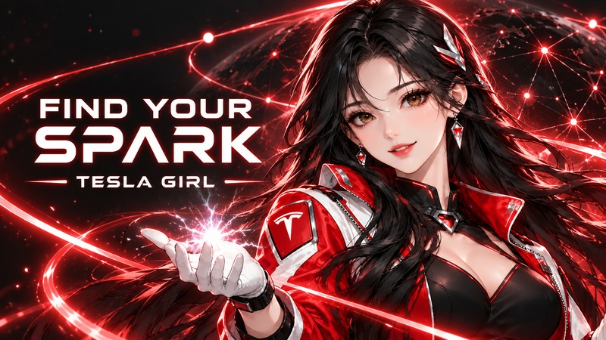

Post 07 Community conversation
If Tesla Girl had one rule for the timeline, it would be this:
Stay curious.
Share an idea, ask a question or show us your favorite red-and-white character moment.
The next spark could be yours.
#TeslaGirl #Community
Image: 03-find-your-spark.jpg

Post 08 The future has a spark
The future has a spark.
For Tesla Girl, it starts where anime creativity, on-chain curiosity and AI agent ideas meet.
Follow the character. Join the conversation. Bring your own perspective.
#TeslaGirl #AIAgents
Image: 01-meet-tesla-girl.jpg

